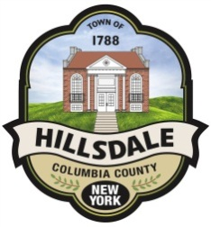

PLANNING BOARD AGENDA FOR 11/8/21

CHAIRPERSON COMMENTS

Announcements

Approval of minutes from 9/13/21

NEW APPLICATIONS

Informational Meeting
File #: 2021-015 | Applicant: Debra Adamsons Merrill
129 Hillsdale Neighbors Road | Tax Map ID#: 145.-1-5

Applicant is looking for permission to develop a lot at Hillsdale Neighbors. It has been surveyed.

Site Plan
File #: 2021-016 | Applicants: David and Barbara Thomas
632 County Route 21 | Tax Map ID#: 115. ??

Applicants are looking to develop a lot in the ridge line.

