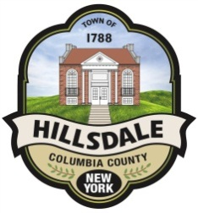

PLANNING BOARD AGENDA FOR 8/9/21

CHAIRPERSON COMMENTS

Announcements

Approval of minutes from 7/12/21

NEW APPLICATIONS

Subdivision
File #: 2021-013 | Applicants: Irene Gibson
Minor Subdivision | Tax Map ID#: 134.-1.9

Applicant would like to subdivide a188 acre parcel into one of 168.9 acres and one of 18.7 acres.

Site Plan Review
File #: 2021-014 | Applicants: Martin Ping Representing Hawthorne Valley Waldorf School
Property location: 321 County Route 21c | Tax Map ID#: 104.-00-01-15
Applicant would like to build a pavilion over the basketball court.

